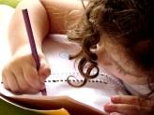  Literacy and WCR  In Talk 4 Writing, this half term, Year 3 will be exploring the genre of a Nail Soup story. We will be writing our own Nail Soup story focusing on the key literary devices to help set the scene and build the tension. We will then be writing instructions on how to make soup.  Year 3 will be reading “The Abominables” from Pie Corbett’s reading spine. | Maths  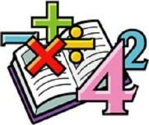  In Maths, we will continue looking multiplication and division.  We will continue to develop our arithmetic skills to which we can apply to help us solve problems.  We will continue to complete daily times tables practise. | Science    In Science, this half-term, we will be look at the topic “Forces” We will investigate how magnetic forces can act at a distance. We will observe how magnets attract or repel each other and attract some materials and not others  We will identify some magnetic materials  We will predict whether two magnets will attract or repel each other, depending on which poles are facing each other | Computing  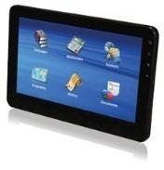  In Computing, Year 3 will be.  learning about computer networks, including the internet.  We will learn about how the World Wide Web offers opportunities for communication and collaboration  We will look at software that can be used to collect, analyse, evaluate and present data and information
  Humanities  In History, Year 3 will be focusing on the The Tudor Dynasty. We will be learning about Henry VIII and his influence on religion and the church during his reign.  We will compare lifestyles, including jobs and clothing of Tudors.  We will learn about how different classes from the highest to the lowest status lived. | Overdale Community Primary School  Year 3 Spring 1 – 2025  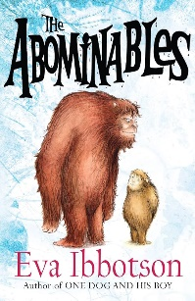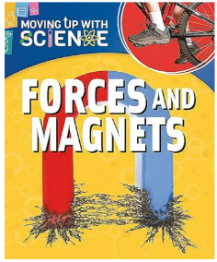 |  | 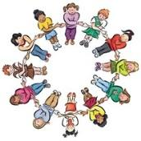  RHE/PSHE  This term in PSHE, Year 3 will be looking at our Citizenship.  Year 3 will be learning about children’s rights; exploring why we have rules and the roles of local community groups, charities and recycling and an introduction to local democracy
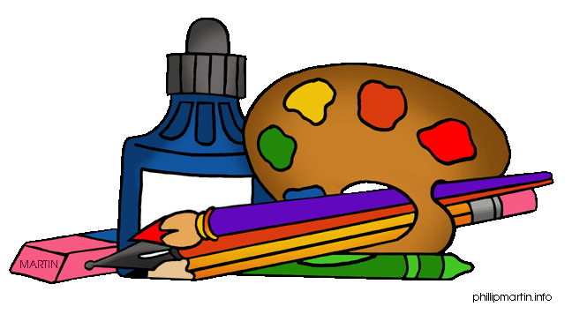  Art and DT  In Art, our focus will be on the use of shape and colour.  We will look at the artist Henri Matisse as we use our observations to improve our own mastery of art and design techniques, including drawing, painting and collage. |   PE  This term in PE, Year 3 will be honing our football skills with the help of specialist football coaches from Hawkes Health. | 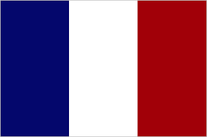  French  In French,  Music  In Music, the focus will be on developing our singing technigue. Year 3 will be play, perform improvise and explore music linked to the Tudors with the support our music specialist Mrs Leggitt. |   RE  In RE this half term, we will be looking at the key question.  “Why do people pray?”  We will look at prayer across a range of religions and identify similarities and differences.  Rev Sam and the Faith in Scarborough Schools team will carry out a prayer workshop for us

Reading: Children will be expected to read their home reading books three times a week with a written comment from a parent in their reading record. Books will be changed when children complete a book review of their current reading book or in a phonic session.
Maths: Children will be tested on their times tables throughout the week as well as a weekly arithmetic test to build their mental arithmetic confidence.
Homework: Year 3 have been given homework book with weekly tasks to complete that relate to learning that has been delivered during the week. Year 3 will have a maths task, spelling/handwriting task and a foundation subject task to complete. This is handed out every Friday and is expected to be returned by the following Friday.

